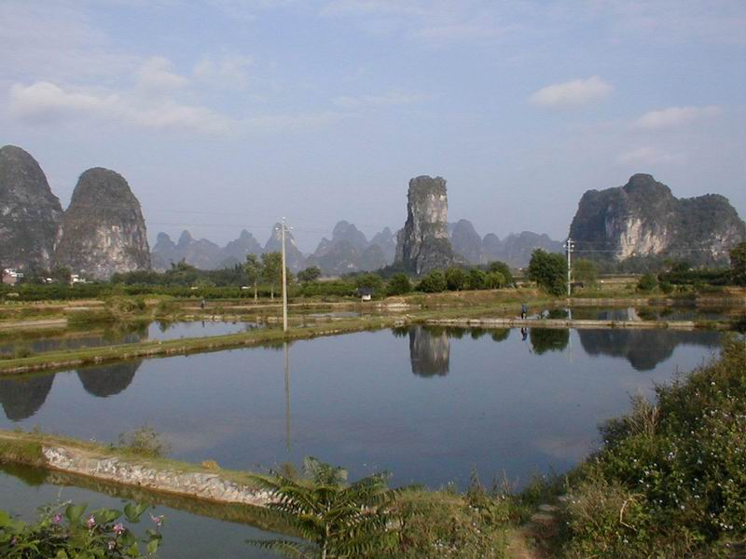

Figure 15: Tower karst and cone karst reflected in fish farming ponds south of Yangshuo.

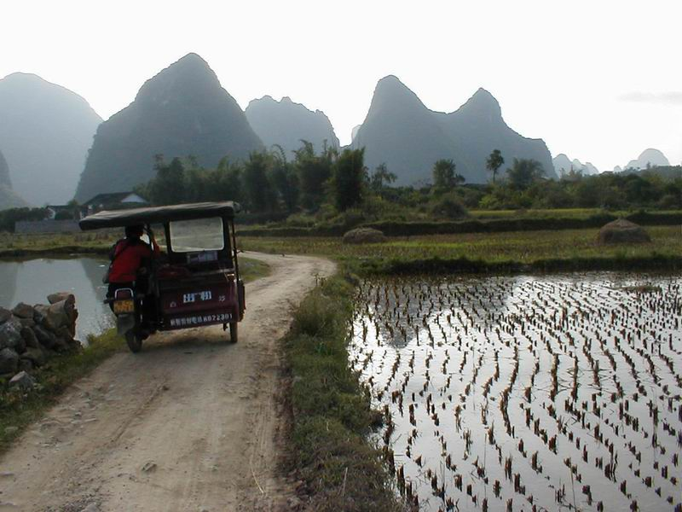

Figure 16: “Biscuit-tin” taxi on country road near rice paddies and cone karst hills.
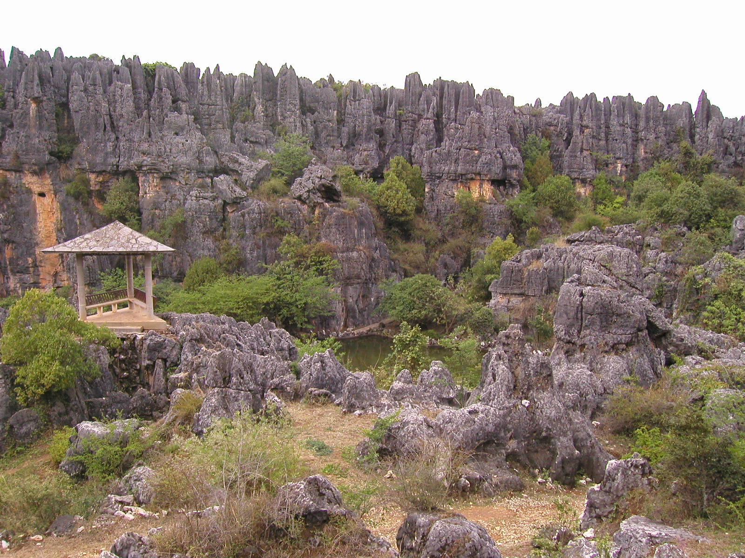

Figure 17: Eroded section of the inclined “Yungui” plateau karst with grikes and fissures at Naigo, north of Lunan (20km from Shilin Stone Forest) in Yunnan Province.
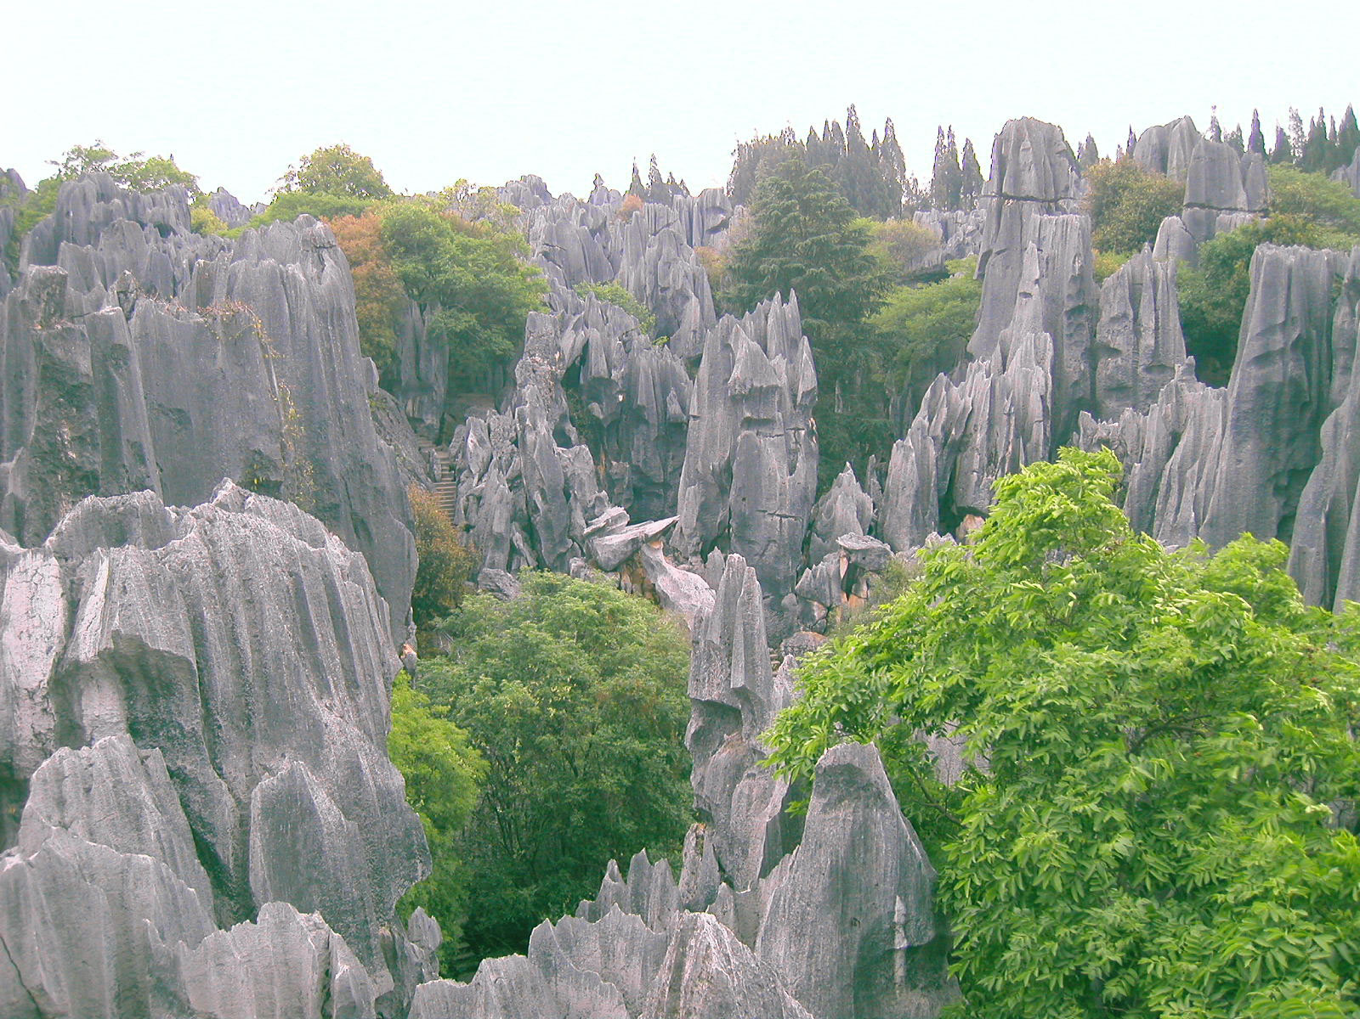

Figure 18: Pinnacle karst in Shilin Stone Forest, east of Kunming in Yunnan Province.

